Congressional Guidelines for Abusing Women
Source: http://www.ejfi.org/News/Congressional_Guidelines.htm
By Terri Lynn Tersak
March 16, 2008

© 2005 - 2008 True Equality Network – All rights reserved – www.True-Equality.org. Used with permission.


This report explores how the very same systems that are destroying families for profit are also victimizing the women who participate in it. It also exposes who profits from this system and why they oppose any effort to change what is happening. The guidelines and funding systems for all of this are created through Acts of Congress.
The most appalling exposé of the series “How the Failures of Welfare Reform Created Our Lawless Courts,” has to be how claims of Domestic Violence (DV) and restraining orders are systemically exploited. This has resulted in nearly worldwide-institutionalized protectionism, economic interventionism, and regulatory policies unlike any previously seen in the history of civilization. Equally appalling is how the same systems victimize the women it claims to serve, under the guise of "protecting" them from abuse.
Since the adaptation of welfare reform and the passage the Violence Against Women Act (VAWA), the social policies and civil liberties of the United States have collapsed with regard to family law, causing our legislatures and courts to become the shills of radical ideologues. At times it seems that law enforcement officers have been reduced to acting as little more than the personal hit men for vindictive intimate partners.
True Equality Network(TEN), spent almost five years interviewing over 15,000 plaintiffs of domestic violence claims just before they entered the courtroom. Subsequently, prominent members of the counties the plaintiff surveys were conducted in were asked to interview the judges who heard these cases. All of the sitting judges interviewed corroborated the investigation's finding of pervasive levels of false claims of domestic violence in divorce and custody cases.1
Moreover, the judges who were interviewed expressed concern that their District Attorneys were not prosecuting these acts of fraud and stated they were aware that many of the plaintiff's attorneys were scripting their clients' statements, in effect suborning perjury in violation of the highest canons of law.
The first follow-up investigation to our court surveys involved the infiltration of abuse shelters. The women of TEN went to abuse shelters and acted as recent victims of DV, while others gained employment in abuse shelters. What we witnessed -- as corroborated by actual shelter clients, supporters, and service providers of the shelters -- is a horrifying demonstration of what happens when malignant narcissism becomes the foundation of government policy.

Fraud and Abuse Under the Guise of Protection
Our shelter investigation observed the daily operations of 417 abuse shelters in the United States and a few in Canada over an eighteen-month period. The following is a sampling of the fraud and abuses the prior listed congregate witnessed.
- The confiscating of Food Stamps (EBT cards) and pooling of the grant monies to buy food for the staff and entire facility. These actions are in direct violation of federal law (see: 7 USC 2024(b), (c) and (g)), which is punishable by fines, imprisonment, and/or forfeiture of property. Moreover, these actions probably constitute violations of applicable Food Stamp program regulations and state level statutes and regulations.
- Forcing women and their children who have sought refuge at the shelters to act as cleaning and maintenance staff for the facility without pay even though the shelters have full-time personnel who are paid for cleaning and upkeep of the facility.
- Requiring the women and their children seeking refuge to provide labor to the shelter in order to get funds that they are actually automatically eligible for without providing unpaid work.
- The use of abusive coercion tactics to convince the women they are "lucky to be tolerated" and have a place to stay when they object to being treated like prisoners of the state.
- The withholding of grant monies and threats of, and actual eviction from the shelter if a woman legitimately objects to her children being used as unpaid laborers or speaks out against staff maltreatment of residents or their children.
- Children, especially teenage boys often used as the emotional and verbal "whipping posts" by the shelter residents.
- Residents were permitted, if not encouraged, to inappropriately expose children and teens to the details of their experiences of sexual abuse.
- Counseling services for children and teens were not provided.
- Theft and tampering of mail sent to residents, including items sent after they left the facility.
- Residents who speak out against the maltreatment of their children or themselves are evicted from the shelter, then denied access to the facility to retrieve their belongings, which are placed in common access areas where other residents are allowed to look through and buy, or take their property (including personal information and vital records) or their property and vital records are kept by the staff.
- Food purchased by women who, or their children, have special dietary requirements due to medical or religious reasons is confiscated and eaten by the staff or distributed among the other residents without the women's knowledge or permission.
- Policies requiring a three to seven day "lock in" where new residents are not allowed to leave the facility for work or school, often causing the women to lose their jobs. No prior notice is given of this policy when women apply for shelter.
- Women are threatened with eviction from shelters who are contacting their partners, when in fact the shelters are supposed to be neutral while providing safe haven to allow the client autonomy to make her own choice in regards to her relationship.
- Women who choose to seek counseling and repair their families for religious reasons or personal choices are routinely accused of lying about the abuse and/or threatened with eviction from the shelter.
- Women are threatened with eviction from shelters for disagreement with and refusing to participate in “lesbian experimentation” promoted as “emotional therapy.”
- As punishment for speaking out against maltreatment, the shelter staff would freely discuss the contents of their clients' files with other residents, including specific detailed descriptions of sexual abuse and humiliation.
- Some shelters falsely label themselves religious entities or non-profits simply to avoid having to comply with the tax laws.
- Regulations regarding the training and employment qualifications for shelter workers were lacking often resulting in unqualified or poorly trained staff.
- Women are routinely denied shelter admission or evicted from shelters for simply having a disability or if staff feels they are not independent enough. Many shelters label their programs as working on an "empowerment" model and claim that disabled women or their children who need assistance are not "empowered" enough.
- Shelters maintain a "banned" list of residents even when they are the only abuse shelter for several hundred miles. The women can be placed on the banned list for:
  - Personality conflicts and disagreement with staff members.
  - Choosing to try to work things out with their partners.
  - Being suspected of speaking to their partner on the phone.
  - Being the subject of rumors spread after they have left.
- The public is told shelter services are free to the resident, while many have per diem charges to residents, require they provide labor, the surrender of food stamps, and other public assistance benefits during their stay.
- The complete absence of oversight of the distribution of donations of clothing, money, and other items needed by shelter residents, e.g., diapers.
- Residents are required to use clothing allowance grant monies to purchase "dating clothes" to be worn at "Socials" held by the shelter for male financial contributors to the shelter, and the attorneys and law enforcement officers working the residents' cases. Cases where the shelter staff privately referred to these events as, "Buy a co-dependant night" were noted.
- Requiring residents to accept physical beatings from staff members and other residents to "improve" the appearance and extent of their injuries for their court appearances.
- Drug dealing and use being permitted within the shelters.
- Consumption of alcohol being permitted within the shelters and in the presence of children and teen residents.
- The operation of "call girl" services, using residents as the prostitutes.
- Permitting and promoting "pandering" of residents into prostitution services, including cases where law enforcement officers were the "pimps."
- Telling residents to go to local "strip clubs" and participate as strippers in "amateur nights" to help them "vent" their frustrations and hostilities.
Many of the violations of federal law and civil and human rights cited above mirror the abuses many of the shelter residents and their children were desperate to escape. Most notable are the use of threats and intimidation tactics, financial and social control mechanisms, and sexual servitude the shelter residents were subjected to by the shelter's staff and supporters.
When these types of exploitations occur outside of the publicly funded systems, abuse advocates are likely to rightfully call them "horrifying." Nevertheless, when the same abuses are committed by individuals employed by the publicly funded abuse victims' support systems, the advocates will profess to their need and declare the operations a success story.
As with many of our social programs today, if someone violates the basic civil and human rights of another, they are condemned and often incarcerated. However, when the same abuses are committed under publicly funded government programs our investigation shows they are called "protection," "support," or "intervention."
Review of the complaints from former abuse shelter residents and staff makes this author wonder if VAWA's name was a Freudian slip. The Violence Against Women Act has failed to protect women from violence; it has contributed to a reversal in the decline of intimate partner violence and has victimized the very people it claims to serve.
Review of the complaints from former abuse shelter residents and staff makes this author wonder if VAWA's name was a Freudian slip. The Violence Against Women Act has failed to protect women from violence. It has contributed to a reversal in the decline of intimate partner violence and has victimized the very people it claims to serve.
It is no wonder that VAWA was not named something like "The Prevention of Domestic Violence Act," because it does not prevent it or protect from it. In fact, VAWA is reversing the decline in Intimate Partner Violence (IPV) and Intimate Partner Homicide (IPH) against women. Maybe it was really designed to simply decriminalize beating your spouse so more people would assault their partners, thus causing "violence against women," which it clearly has.
Think about this before you call someone misogynous, ladies. It is so obvious that the real women-haters are seated in the United States Senate and House of Representatives. They are who created and enacted the congressional guidelines for abusing women that we live and suffer by today.
However, not all the shelters we investigated were problematic. On the contrary, the sad fact is many of the shelters that are providing good service to the abused have to put up with a system that pays late, often fails to pay at all for valid services provided, or close their doors.

The “Violence Against Women Act” Lives Up to Its Name
While our States’ domestic violence coalitions have been busy lobbying against anything that might change the outcome of custody decisions that take children by the millions away from their fathers. The patterns for female victimization of IPH followed the national crime statistics trends. There has been no change to these trends for women despite the billions of tax dollars we have wasted on partner violence programs that have little effect, or exacerbate the problem (See Figure 1).2, 3
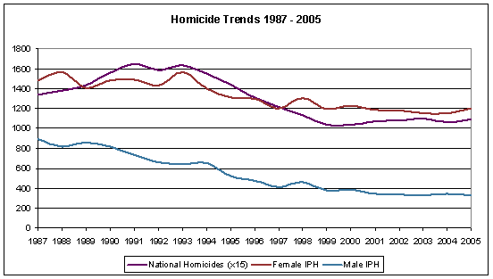
Figure 1: See Figure note a

From 1976 through 1994 before VAWA was enacted and welfare reform was still being debated in the US Congress, cases if IPH between intimates fell 36.7 percent, with an average annual reduction of 58 cases. Since 1995 through 2005, after both VAWA and welfare reforms were enacted and deployed, the decline in IPH has only been 17.6 percent, with an average annual reduction of 32 cases (See Figure 2).4

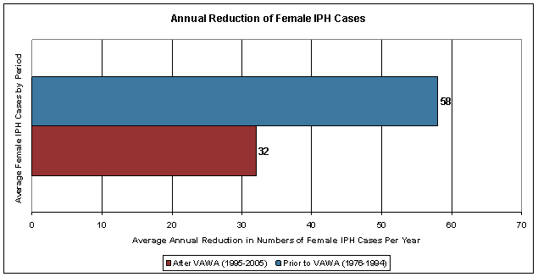
Figure 2:

Therefore, since the inception of VAWA and welfare reform the decline in the number female IPH cases per year are dropping at almost half the rate (44.8%) of decline before any federal intervention programs were enacted.5
Moreover, research shows that IPH cases increases are approaching 60 percent in some of the 30 states that have enacted mandatory, recommended, or preferred arrest laws promoted by VAWA (See Figure 3).6

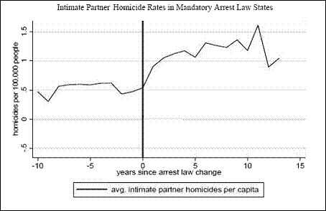
Figure 3:

During the same period, federally funded interventions for women had a similar absence of positive effect on IPV. Research shows that despite spending billions of tax dollars on intervention systems violent crime against women in all offender categories fell at almost identical rates and far below the rates some offender categories did for men (See Figure 4).7

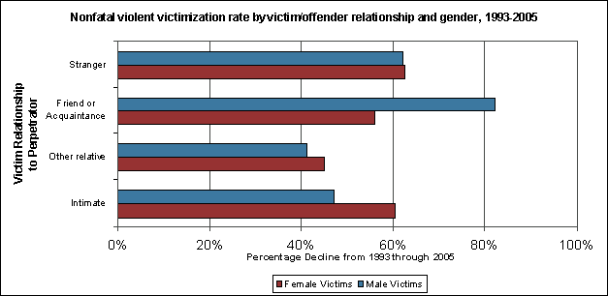
Figure 4:

However, the abuse coalitions are far more interested in staying in business and promoting ideology based on fallacious arguments than they are in providing service to the abused. Given the findings of empirical studies that show IPV cases are perpetrated almost equally by the sexes and that half of all the IPV cases in our country are reciprocal, the dual arrest rates should be about 50% nationally. The other half would be split equally between males and females. However, not one state is close to that arrest ratio today. 8
Moreover, the domestic violence coalitions have stated they have set a nationwide guideline to limit the dual arrest rate to 5% of all IPV incidents reported.9 All this while state domestic violence coalitions focus primarily on preventing losses to their funding sources and disregard the purposes for which they were originally funded. The domestic violence coalition does this at the expense of the safety and well-being of their client base and the children of the victims.
Today’s arrest rates are additional proof of bias in the system and a believed primary cause for the decline in 911 calls. The domestic violence coalitions -- who are support to be advocates for the abused, not just for female victims – argue that dual arrest polices are what is keeping women from calling for fear that they will be arrest too. Did it ever occur to them that intrusive arrest policies just might be what keeps male victims from calling for help too?
Evidence that our abuse policies are silencing the voices of victims of both genders is found throughout the country. A fifteen-year study of 911 calls in Colorado Springs, CO illustrates the impact on requests for assistance mandatory arrest laws have had on victim’s willingness to seek help in domestic disturbance situations (see Figure 5).10 A similar trend is seen in a California domestic disturbance 911-call study 11and those conducted in other states.

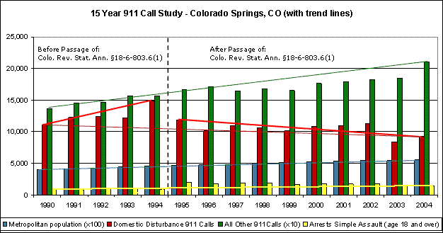
Figure 5:

An expansive annotated list of government and academic studies supporting the outlined concerns above is in the article, “Domestic Violence Awareness Month,” by Richard L. Davis.12
VAWA has spawned an abuse industry that continually expands the definition of domestic violence and condones the filing of false allegations, while ignoring the needs of true victims. However, one great quote sums up the effects of imposed intervention in abuses cases.

“We have no evidence to date that VAWA has led to a decrease in the overall levels of violence against women.”
—Angela Moore Parmley, PhD, Department of Justice 13

The Office of Violence Against Women: An Equal Opportunity Abuser
Social indoctrination has taken its toll on our society. Today, the American male is taught to believe that violent behavior by women 14 is “comical”15 and that pusillanimous submission to violent women means you are “sensitive” and therefore worthy of being with a woman. While at the same time any type of violent behavior on the part of a man requires they receive “social retraining” and/or be incarcerated.
Given the broad acceptance of this double-standard, male victims of domestic violence are often denied service and as reported in the Final Report of the Pennsylvania Supreme Court Committee on Racial and Gender Bias in the Justice System (Chapter 10 page 398); 16

“Courts have also raised credibility issues about males alleging domestic violence. Many people scoff, for example, at the very idea of a man seeking protection under the domestic violence statute.”
This social perspective enforced through ideologically based government policy and advocacy research has created, arguably, the worst cases of government sponsored discrimination and civil and human rights violations since the abolition of slavery and one of the grossest lack of Congressional oversight and government spending accountability in our nation's history.
The Department of Justice's Office of Violence Against Women (OVAW) openly violates their constitutional constraints and mandates under the Omnibus Crime Control and Safe Streets Act of 1968 17, and VAWA itself 18 forbids discrimination on the basis of race, color, religion, national origin, or sex in the delivery of services funded by the Department of Justice. By completely excluding service to men from four of the eleven programs funded under VAWA and limiting service levels in the other seven, they discriminate against men. (See Table 8).
For example, the United States Department of Justice, Office of Violence Against Women (OVAW) reports that 37% of the victims of domestic violence are male. While their own records show that, an average of only 7.3% of the funding set aside for domestic violence victims’ services has been used to provide service to male victims of partner abuse (See Figure 6).19

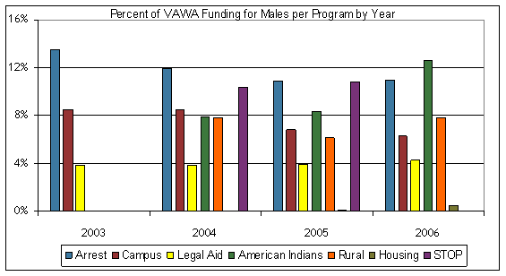
Figure 6:

The most pitiful showing of the lack of support for male IPV victims is the measly 0.3% of the VAWA funding set aside for housing doled out to support the reported 37% of male victims.20
Moreover, a large portion of the funding allocated to programs managed by OVAW cannot be accounted for by the United States Congress' Government Accountability Office (GAO). (Sources: GAO Reports: GAO-02-05,21GAO-02-641T,22 and GAO-02-309 23). Between the funding set aside for Victims of Crime Act, Family Violence Prevention and Services Act, and Violence Against Women Act about one billion dollars a year is allocated to service abuse victims. However, the abuse support systems suffer from a culture rife with fraud, embezzlement, financial misconduct, mismanagement of grant monies, and waste. The problem is so widespread today some grantees are showing discrepancies as high as 99% of the grants received.24
The OVAW also ignores the facts proffered in CDC reports 25 and more than three decades of scholarly studies 26 showing that men comprise a slightly larger victim group of IPV and Dating Violence as they are victimized not only by their partners but also by the ideologically based justice system when they seek help. This demonstrates that the United States Department of Justice utterly disregards their constitutional constrains and requirements under federal law, supports and funds the discrimination against a subject class, men.

Follow the Money
Top
TEN is often asked why such a dysfunctional, abusive, and corrupt system is so broadly supported. That answer requires some understanding of who benefits from the continuation and expansion of the funding alleged to assist victims of domestic violence and how they get the funding.
As covered in part one 27 of the Lawless Courts series, false claims of partner violence is an expansive facilitator that allows the states to pull funding from numerous sources of federal funding unrelated to domestic violence.
Even our state legislatures have begun to recognize this pervasive abuse of process. For example, the Hawaii Senate passed Resolution 40 regarding the misuse of domestic violence restraining orders after finding that over 87 percent of divorce cases in their state included allegations of domestic violence and temporary restraining orders. The West Virginia Legislature has passed House Bill 3065 that makes making false reports of child abuse, sexual abuse or domestic violence a criminal offense. In addition, the General Assembly of the State of Illinois introduced HB1705 28, which would subject anyone stating false information in a sworn petition for a protective order to a perjury prosecution.
The most dubious result of restraining order abuse is the substantial increase in child support incentive funding to the states produced by permitting, and even overtly promoting false claims of domestic violence as a valid reason to keep one parent away from their children. As noted in countless books,29 reports,30 and articles 31,32 the time each parent has with their child has the single greatest impact of the amount of child support awarded to the custodial parent. It is also a well-documented fact that the use of false claims of domestic violence and abuse of restraining orders is the most effective way to reduce one parent's time with their child. Therefore, increasing the awarded child support to the custodial parent and resulting in highly augmented incentive funding to the states.
However, the custodial parents and the states are far from the only victors in this reign of terror on the American family, parenthood, fathers, and our civil liberties.
Child support is a source of tax-free revenue to the recipient of the child support payments. This revenue is derived from the after tax (net) income of the obligor. Therefore, the child support obligor is also the obligor for the taxes due on this income, not the recipient.
Second, being that the child support system of our welfare reform is an “income shares”33 model and as it has no meaningful basis in the cost of rearing children, it amounts to secondary or “hidden” alimony.
Third, and by no means last, this tax free revenue to the custodial parent requires no accountability to anyone for what it is used. Not even to the child who it purportedly supports, or the non-custodial parent who has rightfully paid the taxes due on the monies alleged to be used to support their child.
In the preponderance of custody cases, it is the children's mother who receives custody, which has created a windfall to the manufacturers of women's products through an artificially created increase in the deposable revenue for many single mothers. That fact, in itself, acts to create divorce, discourage marriage, and destroy the children.
Seeing how these companies -- such as manufacturers of women's clothing, cosmetics, and accessories -- stand to lose an incredible amount of revenue if the system changes, it should be of no surprise to anyone that they are some of the largest contributors to the opposition of presumptive equal parenting laws and changes to our domestic violence laws. This is not accomplished through direct action on their part, but rather through the support of radical advocacy groups, the states' domestic violence coalitions, and through the sponsorship of television programming and print media that helps promote the myths that only men are abusers, only rich men don't pay child support, and women are always and the only victims of abuse and nonpayment of child support.
These myths continue to flood the airways and influence public perception, government policies, and court guidelines despite long standing, incontrovertible evidence that the complete reverse is closer to the truth. (Two fantastic reads on how deep this corruption of public policy goes are covered by Dr. Stephen Baskerville in his article, “From Welfare State to Police State, 34 and his book, “Taken Into Custody 35).

Promoting Ideology at the Expense of Our Children’s Best Interest
Top
State level organizations working to see presumptive equal parenting laws enacted (such as what is constructed in the sample legislative template, Uniform Parental Rights Enforcement and Protection Act (UPREPA),36 now promoted in four states) are finding themselves embattled with their states' domestic violence coalitions, as well as the bar association and their own governors.
Both the domestic violence coalitions and respective state bar associations claim that by opposing presumptive equal parenting time they are working for “the best interest of the child.” Notwithstanding reports that show primary custody arrangement have caused numerous social and legal problems for the children in these arrangements, including; substance abuse,37child abuse,38, 39 school disciplinary problems,40 drop-outs,41 sexual promiscuity,42 juvenile delinquency,43 higher incarceration rates,44 homicide,45 injuries,46 suicide,47 and poverty.48,49 Moreover, governors have clearly stated it is the loss of federal funding that concerns them most in their decisions on family law matters, such as presumptive equal custody 50 and paternity fraud,51 not the well being of their state's children.
It does not take a village to raise a child as the infamous children's story version of the "Communist Manifesto" has claimed,52 it takes two committed parents. There is no clearer evidence of this simple truth than the academic success exhibited by so many home-schooled children.
Every known presumptive equal parenting legislative effort addresses the critical points involved with abuses. These laws, by design, would only protect the rights of "fit parents," and they clearly state this fact within their language. Therefore, this is not a domestic violence related matter and should not be professed to be one, especially by any organization that's funding is in any way derived from tax dollars.
So why are the states' Domestic Violence Coalitions, which list themselves as non-profit organizations, lobbying against equal custody legislation? Well, where is their funding coming from? Not all of it comes from the US Department of Justice or other tax dollar funded sources. If that were the case, lobbying for or against anything unrelated to domestic violence would be a violation of VAWA (see "Prohibition on lobbying" under 42 USC 13925(b)(10) ).
Worse yet, why are the Domestic Violence Coalitions not focused on their primary mission of seeing that proper services are rendered to the abused, both women and men? This author's opinion is that the abuse industry not only needs victims to stay in business, but also needs the number of victims to increase in order to grow. Therefore, they turn a blind eye to the failures, abuses, and fraud to help keep the numbers up. Without battered bodies to photograph and foment guilt and pity in lawmakers and the general public, they just might lose funding.

The Business of Abuse
Consider these questions. If all abuse magically ended tonight at midnight, how many tax dollar funded jobs would no longer be needed tomorrow morning? What effect would that have on custody decisions? Who would lose revenue as a result?
Any shift in custody policy will cost the manufactures of women products a fortune. Their sales would drop and their stock values will plummet as we see a shift in spending move away from a huge boon these companies have enjoyed since the passage of VAWA and inception of welfare reform, closer to a balance in spending between women's product and companies patronized largely by men. Could this explain their support to the Domestic Violence Coalitions efforts in lobbying against presumptive equal parenting laws and promoting the myth of economic destruction if they are changed?
Then consider the secondary beneficiaries of this one sided spending spree, the media outlets where these companies advertise. Can anyone believe that sponsored television shows like network news, talk shows, and entertainment shows like Dr. Phil, The Montel Williams Show and the others would dare tell the whole truth about the domestic violence industry? That could amount to biting the hand that feeds them.

Could the television networks and their shows abandon the wealth the abuse industry has delivered to them to adopt truly objective investigative reporting? Or will they continue to assist in the destruction of the American family while feeding us sound bites coated in eye candy and enjoy the riches of the blood money gained by permitting male victims of abuse to go unserved and women to be beaten, and then abandoned by the very system built to help them and all abuse victims?

The Greatest Myths of All
Top
Meanwhile, back in the trenches of the gender war, women and men's groups hurl vitriol at each other backed by a seemingly infinite arsenal of fallacious arguments. We witness each side peddling their respective reality distortions to anyone who will listen or is trapped in the path of a ranting advocate's guilt trip.
The women are screaming about how they are controlled and battered by the dark forces of the evil patriarchy, despite clear evidence they are as guilty as men are in perpetrating partner violence, control tactics, and that most cases of partner violence resulting in injuries are the result of substance abuse, personality disorders, selfish indignation and ignorance; not gender or ideology.
They will tell you at the top of their lungs and in flaming emails how fragile and helpless women are, while pounding their fists on the nearest flat surface. Remember one thing girls, actions do speak louder than words.
The men counter with their theory of an anti-male agenda. Really? Most of the legislators who promulgated this social disaster are men, most of the judges are men, and most of the law enforcement officers who will arrest you are men. Are these men's rights groups subconsciously professing that men are inherently self-destructive?
Try this idea instead: Unbridled greed and lust for power are the driving forces behind the problems our government inflicts on its people, both men and women. However, it is the laziness, stupidity, and caprice of the electorate that caused it to happen and keeps the problems growing.
As for the men’s rights activists and the anti-male feminists, they are just convenient pawns manipulated by the real forces of evil that create the ever-growing class division between the haves and the have-nots. We lovingly refer to them collectively as the United States Congress.
Creating systems that keep the people fighting among themselves is by far the most brilliantly conceived political camouflage I have ever heard of. Nothing keeps a person focused away from the truth better than keeping them busy projecting their own hatred toward a group that should be a natural ally, as we are doing between men and women today.
History shows that collective hatred is a powerful tool to unify a nation, as tyrants have done for millennia against foreign countries or religions, even when obviously false pretenses are used to garner support for absurd and hideous actions.
Had our government created as much hatred toward terrorists as has been generated against fathers and spousal abuse over the past decade, no would care what we were doing in Iraq, how much it cost or how long it would take to do the job. Even if it were clear that every facet of the reasons behind attacking was proven false, still, not only would no one care, they would demand more.
This is not a guess. Based solely on ideology and government-funded propaganda, today the generally accepted perception is that only men are abusive in intimate relations, and only women are abused. And women are never the abuser. The long established facts clearly demonstrated by hundreds of peer-reviewed research studies show that none of this is true. Yet radical ideologues demand ever more draconian intervention with total disregard for due process and the rule of law. There is no effective oversight of what the funding is really spent on; and that the present system not only fails to serve, but abuses the abused. Yet zealots demand more of the same and ever more government funding. This is a classic approach of bureaucracies; if the current approach does not work the obvious solutions is to through more money at the problems and hire more bureaucrats to promote the party line.

Sometimes, it's What They Don't Say That Tells the Whole Truth
Top
In the 2004 Election cycle “Family Values” was the call to arms by most of those seeking election and reelection. This time the candidates seem to be working overtime to keep from having to so much as mention the subject.
Maybe they know the electorate realizes that the only real value an American family has to our Congress is in how much funding they can feed to their favorite special interest group to destroy children, families, and marriage. On the other hand, maybe it is because we have let them run amok without a challenge for so long they just do not care what we think anymore, nor should they. We earned what we have today and did nothing. Thus, we got just what we asked for.
If the US Congress wanted to be honest with the American people about what really happens on Capital Hill, they would change the call to order of both Houses of Congress to say:
“Ladies and Gentlemen, the Constitution has left the building; may truth, justice, and the American way be damned.”

Terri Lynn Tersak is the President and CEO of True Equality Network.

© 2005 - 2008 True Equality Network – All rights reserved – www.True-Equality.org. Used with permission.

References:
Top

Figure notes:
a The dataset was scaled by dividing the raw data for the national homicide figures by fifteen to create a visual overlay of the trend for the benefit of readers that only look at the pictures.

Endnotes:
1 True Equality Network, Complaint of Systemic Abuses by Legal Services Corporation Grantees and the failure of the by Legal Services Corporation Office of Compliance and Enforcement to respond, 2006 http://www.True-Equality.org/reports/OIG-LSC_Complaint_05-19-06.pdf
2 Catalano S. Homicide trends in the U.S: Intimate homicide. Washington, DC: US Department of Justice, 2006. http://www.ojp.usdoj.gov/bjs/homicide/tables/intimatestab.htm (See Tables 1 and 2)
3 U.S. Department of Justice, FBI, Criminal Justice Information Services Division Crime in the United States by Volume and Rate per 100,000 Inhabitants, 1987-2006 http://www.fbi.gov/ucr/cius2006/data/table_01.html (See Table 2)
4 US Department of Justice, Office of Justice Programs, Bureau of Justice Statistics, Nonfatal violent victimization rate by victim/offender relationship and gender, 1993-2005, http://www.ojp.usdoj.gov/bjs/intimate/table/vomen.htm (See Table 3)
5 Ibid. en 4.
6 Iyengar, R., Does the certainty of arrest reduce domestic violence? Evidence from mandatory and recommended arrest laws, National Bureau of Economic Research, 1050 Massachusetts Avenue, Cambridge, MA 02138, 2007 (See Table 4 for states effected)
7 RADAR - Respecting Accuracy in Domestic Abuse Reporting, Has VAWA Delivered on its Promises to Women? 2007, http://www.mediaradar.org/docs/RADARreport-VAWA-Has-It-Delivered-on-Its-Promises-to-Women.pdf (See tables 6 and 7)
8 Hirschel, D. et el., Explaining the Prevalence, Context, and Consequences of Dual Arrest in Intimate Partner Cases, National Institute of Justice, Office of Justice Programs, April 2007, Document No.: 218355, http://www.ncjrs.gov/pdffiles1/nij/grants/218355.pdf
9 Jacqueline Seibel, Milwaukee Journal Sentinel, Change in domestic violence law designed to be less hostile toward victims, April 18, 2006, http://www.jsonline.com/story/index.aspx?id=416895
10 Corry, C. Principal Effect Of 1994 DV Law In Colorado Springs Is Reduction In 911 Domestic Disturbance Calls To Police Equal Justice Foundation, http://dvmen.org/dv-111.htm (See Table 5)
11 California Department of Justice, Criminal Justice Statistics Center, California Domestic Violence-Related Calls for Assistance 1986 - 2006, http://safestate.org/documents/DV_Calif_DV_related_Calls_for_Assistance__1986_2006_ADA.pdf
12 Davis, R. L. , Domestic Violence Awareness Month, September 18, 2006, http://www.thepriceofliberty.org/06/09/18/davis.htm
13 Parmley A. Violence against Women Post VAWA. Violence Against Women Vol. 10, No. 12, 2004. p. 1424.
14 YouTube, BEAT DOWN, NOTE: This video is not suitable for minors (even though YouTube has it listed as, “Category: Comedy”), February 27, 2006, http://www.youtube.com/watch?v=CfmrJwRLL0s (login and age verification required)
15 YouTube, Fat Chick Beat Down, NOTE: Language and descriptive text contains derogatory terms. Category: Comedy, June 22, 2006, http://www.youtube.com/watch?v=wm2pMpf7rIg
16 PA Supreme Court Committee on Racial and Gender Bias in the Justice System, Final Report of the Pennsylvania Supreme Court Committee on Racial and Gender Bias in the Justice System (Chapter 10 page 398); http://www.courts.state.pa.us/Index/supreme/BiasCmte/FinalReport.pdf
17 Omnibus Crime Control and Safe Streets Act of 1968, 42 USC 3789d(c)(1). The law states, "No person in any State shall on the ground of race, color, religion, national origin, or sex be excluded from participation in, be denied the benefits of, or be subjected to discrimination under or denied employment in connection with any programs or activity funded in whole or in part with funds made available under this chapter." The penalties for violating these requirements are described in 42 USC 3789d(c)(2). http://www.usdoj.gov/crt/split/42usc3789d.htm
18 Violence Against Women Act 2005, 42 USC 13925 (b)(8), "Nothing in this title shall be construed to prohibit male victims of domestic violence, dating violence, sexual assault, and stalking from receiving benefits and services under this title." http://frwebgate.access.gpo.gov/cgi-bin/getdoc.cgi?dbname=109_cong_public_laws&docid=f:publ162.109.pdf
19 RADAR - Respecting Accuracy in Domestic Abuse Reporting, RADAR Request Reveals VAWA Usage Data by Sex, http://www.mediaradar.org/ovw_foia_data.php (Source for tables 6 and 7)
20 Ibid. en 19.
21 United States General Accounting Office, Byrne Program and Violence Against Women Office Grant Monitoring Should Be Better Documented, GAO-02-25, November 2001, http://www.gao.gov/new.items/d0225.pdf
22 United States General Accounting Office, Testimony: Before the Subcommittee on Crime and Drugs, Committee on the Judiciary, U.S. Senate, Statement of Laurie E. Ekstrand, Director, Justice Issues, VIOLENCE AGAINST WOMEN OFFICE: Problems with Grant Monitoring and Concerns about Evaluation Studies, April 16, 2002, GAO-02-641T, http://www.gao.gov/new.items/d02641t.pdf
23 United States General Accounting Office, Report to Congressional Requesters, JUSTICE IMPACT EVALUATIONS: One Byrne Evaluation Was Rigorous; All Reviewed Violence Against Women Office Evaluations Were Problematic, GAO-02-309, http://www.gao.gov/new.items/d02309.pdf
24 RADAR - Respecting Accuracy in Domestic Abuse Reporting, $1 Billion for DV Programs That Misuse Taxpayer Money and Place Victims at Risk, March 2008, http://www.mediaradar.org/docs/RADARreport-DV-Programs-Misuse-1-Billion-Tax-Dollars-Per-Year.pdf
25 Centers for Disease Control and Prevention, Morbidity and Mortality Weekly Report, Physical Dating Violence Among High School Students --- United States, 2003, 55(19);532-535, May 19, 2006, http://www.cdc.gov/mmwr/preview/mmwrhtml/mm5519a3.htm
26 Martin S. Fiebert, References Examining Assaults By Women on Their Spouses or Male Partners: An Annotated Bibliography, California State University, Long Beach, Department of Psychology, November 2007, http://www.csulb.edu/~mfiebert/assault.htm
27 True Equality Network, How the Failures of Welfare Reform Created Our Lawless Courts (Part One), March 2007, http://www.true-equality.org/Lawless/Lawless-one.htm
28 Illinois General Assembly, Full Text of HB1705, Introduced 2/22/2007, by Rep. Aaron Schock http://ilga.gov/legislation/fulltext.asp?GAID=3&SessionID=3&GA=95&DocTypeID=HB&DocNum=1705&LegID=2476&SpecSess=&Session=
29 Stephen Baskerville, Taken into Custody: The War Against Fatherhood, Marriage, and the Family, Cumberland House Publishing (September 2007), ISBN-10: 1581825943 - ISBN-13: 978-1581825947, http://www.amazon.com/Taken-into-Custody-Fatherhood-Marriage/dp/1581825943/ref%3dpd_bbs_sr_1?ie=UTF8%26s=books%26qid=1196714010%26sr=1-1
30 True Equality Network, Abuses by the States of the Child Support Performance and Incentive Act (CSPIA), January 2006, http://www.true-equality.org/reports/CSPIA_Abuses_Report.pdf
31 Stephen Baskerville, From Welfare State to Police State, The Independent Review, v. XII, n. 3, Winter 2008, ISSN 1086–1653, http://www.independent.org/pdf/tir/tir_12_03_03_baskerville.pdf
32 Ibid., en 27.
33 R. Mark Rogers, Cost Shares Vs. Income Shares, Guideline Economics; http://www.guidelineeconomics.com/costshares/compare.html
34 Ibid., en 29.
35 Ibid., en 31.
36 Muchnick R, Uniform Parental Rights Enforcement and Protection Act (UPREPA), Center for Children's Justice, Inc. July 2005, http://www.true-equality.org/uprepa/uprepa.htm
37 Flewelling R. L. and Bauman K. Family structure as a predictor of initial substance use and sexual intercourse in early adolescence. Journal of Marriage and the Family, Vol. 52, 1990, pp. 171-181.
38 Sedlak A. J. and Broadhurst D. D. The Third National Incidence Study of Child Abuse and Neglect (NIS-3): Final Report, U.S. Department of Health and Human Services, National Center on Child Abuse and Neglect, Washington, DC, September 1996.
39 Whelan R., Broken Homes and Battered Children. London: Family Education Trust, 1993.
40 Nord D. W. and West J., Fathers' and Mothers' Involvement in their Children's Schools by Family Type and Resident Status. Washington, DC: National Center for Education Statistics, 2001. NCES 2001-032.
41 National Center for Health Statistics: Survey on Child Health. Washington, DC: Government Printing Office, 1993.
42 Ibid., en 37
43 Hill M. A. and O'Neill J., Underclass Behaviors in the United States: Measurement and Analysis of Determinants. New York: City University of New York, 1993.
44 Cynthia Harper and Sara McLanahan, "Father Absence and Youth Incarceration," Center for Research on Child Wellbeing, Working Paper #99-03.
45 Cubbin C., Pickle L. W., and Fingerhut L. Social context and geographic patterns of homicide among US black and white males. American Journal of Public Health, Vol. 90, 2000, pp. 579-587.
46 Dawson D., Family structure and children's health and well-being: Interview survey on child health. Journal of Marriage and the Family, Vol. 53, 1991, pp. 573-584.
47 Rubenstein J. L. et al., Suicidal behavior in adolescents: Stress and protection in different family contexts. American Journal of Orthopsychiatry, Vol. 68, 1998, pp. 274-284.
48 Duncan W. S., Economic impact of divorce on children's development: Current findings and policy implications. Journal of Clinical and Child Psychology, Vol. 23, 1994, pp. 444-457.
49 House Committee on Ways and Means. 2000 Green Book, Washington, DC: U.S. Government Printing Office, 2000.
50 Ibid. en 27.
51 True Equality Network, How the Failures of Welfare Reform Created Our Lawless Courts (Part Two), April 2007, http://www.true-equality.org/Lawless/Lawless-two.htm
52 Hillary Rodham Clinton, It Takes a Village, Simon + Schuster Uk (November 2007), ISBN-10: 1847390560 - ISBN-13: 978-1847390561, http://www.amazon.com/Takes-Village-Hillary-Rodham-Clinton/dp/1847390560/ref=sr_1_3?ie=UTF8&s=books&qid=1204213305&sr=1-3

Appendix A - Data Tables:
Table 1: Table 2 Dataset
Bureau of Justice Statistics
Homicide trends in the United States

Intimate Partner Homicides (IPH) - 1976 - 2005
Year | Male | Decline: Cases Per Year | Female | Decline: Cases Per Year | Total  Cases Per Year | Percent  Change From Prior Year | Decline: Cases Per Year
1976 | 1304 |  | 1587 |  | 2891
1977 | 1248 | 56 | 1421 | 166 | 2725 | -5.741958% | -166
1978 | 1159 | 89 | 1473 | -52 | 2721 | -0.146789% | -4
1979 | 1229 | -70 | 1498 | -25 | 2657 | -2.352076% | -64
1980 | 1169 | 60 | 1543 | -45 | 2772 | 4.328190% | 115
1981 | 1232 | -63 | 1558 | -15 | 2727 | -1.623377% | -45
1982 | 1093 | 139 | 1477 | 81 | 2709 | -0.660066% | -18
1983 | 1067 | 26 | 1456 | 21 | 2549 | -5.906238% | -160
1984 | 947 | 120 | 1432 | 24 | 2499 | -1.961554% | -50
1985 | 927 | 20 | 1542 | -110 | 2489 | -0.400160% | -10
1986 | 946 | -19 | 1581 | -39 | 2508 | 0.763359% | 19
1987 | 891 | 55 | 1482 | 99 | 2428 | -3.189793% | -80
1988 | 816 | 75 | 1568 | -86 | 2459 | 1.276771% | 31
1989 | 862 | -46 | 1410 | 158 | 2226 | -9.475397% | -233
1990 | 820 | 42 | 1485 | -75 | 2347 | 5.435759% | 121
1991 | 734 | 86 | 1492 | -7 | 2312 | -1.491265% | -35
1992 | 662 | 72 | 1436 | 56 | 2170 | -6.141869% | -142
1993 | 638 | 24 | 1563 | -127 | 2225 | 2.534562% | 55
1994 | 654 | -16 | 1401 | 162 | 2039 | -8.359551% | -186
1995 | 521 | 133 | 1311 | 90 | 1965 | -3.629230% | -74
1996 | 476 | 45 | 1299 | 12 | 1820 | -7.379135% | -145
1997 | 413 | 63 | 1202 | 97 | 1678 | -7.802198% | -142
1998 | 460 | -47 | 1302 | -100 | 1715 | 2.205006% | 37
1999 | 381 | 79 | 1195 | 107 | 1655 | -3.498542% | -60
2000 | 382 | -1 | 1232 | -37 | 1613 | -2.537764% | -42
2001 | 344 | 38 | 1187 | 45 | 1569 | -2.727836% | -44
2002 | 339 | 5 | 1182 | 5 | 1526 | -2.740599% | -43
2003 | 330 | 9 | 1156 | 26 | 1495 | -2.031455% | -31
2004 | 344 | -14 | 1155 | 1 | 1485 | -0.668896% | -10
2005 | 329 | 15 | 1181 | -26 | 1525 | 2.693603% | 40

1) Source: FBI, Supplementary Homicide Reports, 1976-2005
See the methodology section in 'Additional Information About the Data' for weighting and imputation procedures used.

Table 2: Figure 1 Dataset
Homicide Trends 1987 - 2005
 | Female | Male | National  (x10)
1987 | 1482 | 891 | 2010
1988 | 1568 | 816 | 2068
1989 | 1410 | 862 | 2150
1990 | 1485 | 820 | 2344
1991 | 1492 | 734 | 2470
1992 | 1436 | 662 | 2376
1993 | 1563 | 638 | 2453
1994 | 1401 | 654 | 2333
1995 | 1311 | 521 | 2161
1996 | 1299 | 476 | 1965
1997 | 1202 | 413 | 1821
1998 | 1302 | 460 | 1697
1999 | 1195 | 381 | 1552
2000 | 1232 | 382 | 1559
2001 | 1187 | 344 | 1604
2002 | 1182 | 339 | 1623
2003 | 1156 | 330 | 1653
2004 | 1155 | 344 | 1615
2005 | 1181 | 329 | 1674

National Figures Source (x10): FBI -
Crime in the United States by Volume and
Rate per 100,000 Inhabitants, 1987–2006

Table 3: Figure 4 Dataset
Nonfatal violent victimization rate by victim/offender relationship and gender, 1993-2005
 | Rate per 1,000 females age 12 or older |  |  |  |  | Rate per 1,000 males age 12 or older
 | Intimates | Other  relatives | Friend or  acquaint. | Stranger |  | Intimates | Other  relatives | Friend or  acquaint. | Stranger
1993 | 9.8 | 3.3 | 15.8 | 15.4 |  | 1.6 | 1.6 | 20.1 | 38.8
1994 | 9.1 | 2.9 | 15.2 | 16.8 |  | 1.7 | 2.2 | 18.2 | 38.2
1995 | 8.5 | 2.2 | 14.2 | 13.2 |  | 1.1 | 2 | 17.2 | 33.8
1996 | 7.8 | 3 | 13.1 | 11.8 |  | 1.4 | 1.3 | 16.2 | 29.2
1997 | 7.5 | 2.4 | 12.9 | 10.7 |  | 1 | 1.5 | 16.7 | 26.6
1998 | 7.8 | 2.3 | 11.5 | 9.6 |  | 1.5 | 2 | 15.4 | 24
1999 | 5.8 | 1.9 | 10.8 | 8.9 |  | 1.1 | 1.4 | 12.9 | 20.9
2000 | 4.7 | 2 | 7.5 | 7.9 |  | 0.8 | 1 | 10.7 | 17.4
2001 | 5 | 2 | 8.5 | 6.9 |  | 0.9 | 0.8 | 8.9 | 15.6
2002 | 4.2 | 1.6 | 7.6 | 6.7 |  | 0.7 | 0.8 | 8.3 | 13.9
2003 | 4.3 | 2.1 | 7 | 6.2 |  | 0.7 | 1.3 | 8.6 | 15.6
2004 | 3.8 | 1.4 | 5.3 | 6.3 |  | 1.3 | 1.5 | 8.7 | 12.3
2005 | 3.6 | 1.6 | 6.7 | 6.3 |  | 0.9 | 1.3 | 8.5 | 14.5
The above rates are calculated by dividing the number of victims for a given year by the population for the same year and then multiplying by 1,000.
 | Number of female victims by year |  |  |  |  | Number of male victims by year
 | Intimates | Other  relatives | Friend or  acquaint. | Stranger |  | Intimates | Other  relatives | Friend or  acquaint. | Stranger
1993 | 1,070,510 | 362,290 | 1,729,790 | 1,680,020 |  | 162,870 | 163,250 | 2,055,640 | 3,973,140
1994 | 1,001,780 | 319,340 | 1,679,980 | 1,858,610 |  | 175,490 | 223,840 | 1,880,690 | 3,949,280
1995 | 952,380 | 249,410 | 1,577,930 | 1,466,900 |  | 114,950 | 211,270 | 1,797,750 | 3,523,790
1996 | 877,970 | 342,520 | 1,472,220 | 1,324,830 |  | 150,220 | 132,350 | 1,711,660 | 3,079,250
1997 | 847,260 | 274,330 | 1,461,810 | 1,216,250 |  | 107,400 | 163,580 | 1,784,660 | 2,841,000
1998 | 894,710 | 261,170 | 1,319,390 | 1,105,340 |  | 165,030 | 213,000 | 1,665,070 | 2,587,380
1999 | 671,110 | 218,740 | 1,250,940 | 1,036,390 |  | 120,100 | 156,320 | 1,406,630 | 2,281,410
2000 | 546,070 | 236,850 | 874,480 | 924,860 |  | 85,700 | 111,680 | 1,183,680 | 1,913,620
2001 | 588,490 | 231,070 | 1,011,470 | 819,980 |  | 103,220 | 90,750 | 989,500 | 1,739,780
2002 | 505,800 | 189,140 | 919,860 | 810,960 |  | 83,310 | 96,080 | 946,000 | 1,575,230
2003 | 526,950 | 258,950 | 869,230 | 764,680 |  | 79,410 | 147,300 | 996,900 | 1,818,250
2004 | 475,940 | 172,320 | 660,190 | 786,190 |  | 151,460 | 181,150 | 1,022,040 | 1,446,930
2005 | 457,690 | 204,541 | 845,809 | 792,955 |  | 106,702 | 153,737 | 1,014,234 | 1,731,601
 |  | Female population by year |  |  |  | Male population by year
 | 1993 | 109,176,670 |  |  |  | 102,348,090
 | 1994 | 110,378,010 |  |  |  | 103,369,260
 | 1995 | 111,440,640 |  |  |  | 104,268,820
 | 1996 | 112,490,440 |  |  |  | 105,476,930
 | 1997 | 113,540,360 |  |  |  | 106,893,170
 | 1998 | 114,742,300 |  |  |  | 107,889,420
 | 1999 | 116,243,710 |  |  |  | 108,998,240
 | 2000 | 117,311,860 |  |  |  | 110,168,690
 | 2001 | 118,485,690 |  |  |  | 111,433,410
 | 2002 | 120,466,460 |  |  |  | 113,294,840
 | 2003 | 123,557,510 |  |  |  | 116,470,760
 | 2004 | 124,613,660 |  |  |  | 117,908,470
 | 2005 | 125,914,703 |  |  |  | 119,410,131

Table 4: Mandatory Arrest Laws by State
Mandatory Arrest Laws by State
 |  | State | Year Passed | Code/Statute
 |  | AZ | 1991 | Ariz. Rev. Stat. Ann. §13-3601(B)
Recommended  Arrest States |  | CA | 1993 | Cal. Penal Code §836(c)(1)
 |  | KS | 2000 | Kan. Stat. Ann. §22-2401(c)(2)
 |  | MS | 1995 | Miss. Code Ann. §99-3-7(3)(a)
 |  | MO | 1989 | Mo. Ann. Stat. §455.085(1)
 |  | NY | 1994 | N.Y. Crim. Proc. Law §140.10(4)
 |  | OH | 1994 | Ohio Rev. Code Ann. §2935.032(A)(1)(a)
 |  | SC | 2002 | S.C. Code Ann. §16-25-70(B)
Mandatory  Arrest States |  | AK | 1996 | Alaska Stat. §18.65.530(a)
 |  | CO | 1994 | Colo. Rev. Stat. Ann. §18-6-803.6(1)
 |  | CT | 1987 | Conn. Gen. Stat. §46b- 38b(a)
 |  | DC | 1991 | D.C. Code Ann. §16-1031(a)
 |  | IA | 1990 | Iowa Code §236.12(3)
 |  | ME | 1995 | Me. Rev. Stat. Ann. tit. 19-A, §4012(6)(D)
 |  | NV | 1989 | Nev. Rev. Stat. Ann. §171.137(1)
 |  | NJ | 1991 | N.J. Stat. Ann. §2C:25-21(a)
 |  | OR | 2001 | Or. Rev. Stat. §133.055(2)(a)
 |  | RI | 2000 | R.I. Gen. Laws §12-29-3(c)(1)
 |  | SD | 1998 | S.D. Codified Laws §23A-3-2.1
 |  | UT | 2000 | Utah Code Ann. §7-36-2.2(2)(a)
 |  | VA | 2002 | Va. Code Ann. §19.2-81.3(B)
 |  | WI | 1996 | Wis. Stat. Ann. §968.075(2)(a)
 |  | WA | 1999 | Wash. Rev. Code Ann. §10.31.100(2)
Source: West, 2003. Mandatory arrest states are defined as states where officers have no discretion as to whether to make a warrantless arrest when an intimate partner offense is reported. Recommended arrest states are defined as states where officers are instructed but not required to make a warrantless arrest when an intimate partner offense is reported.

Table 5: Figure 5 Dataset
Seventeen-year compilation of 911 calls, arrests for simple assault and domestic violence court cases in Colorado Springs versus increase in population.
Year | Metropolitan Population |  | All Other 911Calls | Arrests
Year | Metropolitan Population | Disturbance | All Other 911Calls | Simple Assault
Year | Metropolitan Population | 911 Calls | All Other 911Calls | (age 18 and over)
1990 | 397,014 | 11,090 | 136,811 | 885
1991 | 404,419 | 12,297 | 145,078 | 1,080
1992 | 422,062 | 12,472 | 146,462 | 1,128
1993 | 437,105 | 12,210 | 156,783 | 959
1994 | 457,105 | 14,916 | 156,783 | 897
1995 | 469,757 | 11,843 | 166,656 | 2,014
1996 | 478,381 | 10,129 | 171,584 | 1,755
1997 | 486,934 | 10,966 | 164,683 | 1,898
1998 | 498,062 | 10,673 | 167,706 | 1,869
1999 | 509,044 | 10,124 | 165,640 | 1,630
2000 | 516,928 | 10,805 | 176,523 | 1,779
2001 | 535,599 | 10,954 | 178,891 | 1,711
2002 | 543,816 | 11,280 | 182,222 | 1,723
2003 | 547,816 | 8,379 | 184,783 | 1,571
2004 | 554,574 | 9,261 | 210,329 | 1,489
2005 | 587,500 | 12,465 | 248,218 | 1,400
2006 | 599,127 | 12,485 | 239,261 | 1,393
Population: Estimates from U.S. Census Bureau, Colorado Springs metropolitan area. Note that the population of a metropolitan center is always greater than that of the city.
911 Calls: Taken from the annual reports of the Colorado Springs Police Department. Domestic disturbance calls are the sum of "domestic" and "family" 911 calls. Note that the CSPD police report for 2003 does not list any (0) Disturbance - Family 911 calls.
Arrests: for simple assault include other offenses than those involving domestic violence.
Court cases: Values for domestic violence court cases are from Colorado Judicial Branch Annual Statistical Reports

Table 6: Table 7 Dataset
Number of Male and Female Victims Served, By Program, 2003-2006
Grant Program | Jan.-June 2003 |  | July-Dec. 2003 |  | Totals 2003
Grant Program | Male | Female | Male | Female | Male | Female | Total | %Male
Arrest |  |  | 4,265 | 27,217 | 4,265 | 27,217 | 31,482 | 13.547424%
Campus |  |  | 94 | 1,013 | 94 | 1,013 | 1,107 | 8.491418%
Legal Aid |  |  | 1,296 | 32,349 | 1,296 | 32,349 | 33,645 | 3.851984%
Grant Program | Jan.-June 2004 |  | July-Dec. 2004 |  | Totals 2004
Grant Program | Male | Female | Male | Female | Male | Female | Total | %Male
Arrest | 5,428 | 41,501 | 5,965 | 43,060 | 11,393 | 84,561 | 95,954 | 11.873398%
Campus | 124 | 1,092 | 81 | 1,113 | 205 | 2,205 | 2,410 | 8.506224%
Legal Aid | 1,369 | 36,740 | 1,497 | 34,552 | 2,866 | 71,292 | 74,158 | 3.864721%
American Indians | 68 | 2,431 | 360 | 2,541 | 428 | 4,972 | 5,400 | 7.925926%
Rural | 1,195 | 18,923 | 2,120 | 20,218 | 3,315 | 39,141 | 42,456 | 7.808084%
STOP | 30,227 | 260,173 | 30,228 | 260,174 | 60,455 | 520,347 | 580,802 | 10.408883%
Grant Program | Jan.-June 2005 |  | July-Dec. 2005 |  | Totals 2004
Grant Program | Male | Female | Male | Female | Male | Female | Total | %Male
Arrest | 4,670 | 37,037 | 4,528 | 38,107 | 9,198 | 75,144 | 84,342 | 10.905599%
Campus | 44 | 625 | 77 | 1,042 | 121 | 1,667 | 1,788 | 6.767338%
Legal Aid | 1,308 | 31,237 | 1,313 | 33,377 | 2,621 | 64,614 | 67,235 | 3.898267%
American Indians | 207 | 2,074 | 262 | 3,087 | 469 | 5,161 | 5,630 | 8.330373%
Rural | 1,163 | 18,212 | 1,511 | 22,749 | 2,674 | 40,961 | 43,635 | 6.128108%
Housing |  |  | 1 | 954 | 1 | 954 | 955 | 0.104712%
STOP | 29,529 | 244,153 | 29,529 | 244,154 | 59,058 | 488,307 | 547,365 | 10.789510%
Grant Program | Jan.-June 2006 |  | July-Dec. 2006 |  | Totals 2006
Grant Program | Male | Female | Male | Female | Male | Female | Total | %Male
Arrest | 4,686 | 37,947 |  |  | 4,686 | 37,947 | 42,633 | 10.991485%
Campus | 83 | 1,230 |  |  | 83 | 1,230 | 1,313 | 6.321401%
Legal Aid | 1,731 | 38,792 |  |  | 1,731 | 38,792 | 40,523 | 4.271648%
American Indians | 357 | 2,473 |  |  | 357 | 2,473 | 2,830 | 12.614841%
Rural | 1,543 | 18,068 |  |  | 1,543 | 18,068 | 19,611 | 7.868033%
Housing | 11 | 2,182 |  |  | 11 | 2,182 | 2,193 | 0.501596%

Table 7: Figure 6 Dataset
Percent of VAWA Funding for Male per Program by Year
Grant Program | 2003 | 2004 | 2005 | 2006 | Program Averages
Arrest | 13.547424% | 11.873398% | 10.905599% | 10.991485% | 11.829476%
Campus | 8.491418% | 8.506224% | 6.767338% | 6.321401% | 7.521595%
Legal Aid | 3.851984% | 3.864721% | 3.898267% | 4.271648% | 3.971655%
American Indians |  | 7.925926% | 8.330373% | 12.614841% | 9.623713%
Rural |  | 7.808084% | 6.128108% | 7.868033% | 7.268075%
Housing |  |  | 0.104712% | 0.501596% | 0.303154%
STOP |  | 10.408883% | 10.789510% |  | 10.599196%
Year Average | 8.630275% | 8.397873% | 6.703415% | 7.094834%
Average of Dataset |  |  |  |  | 7.302409%

Table 8: VAWA Programs
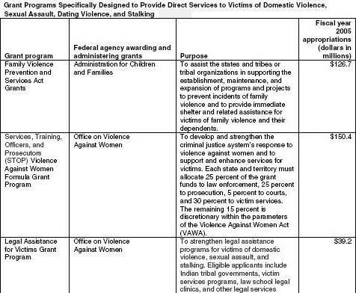
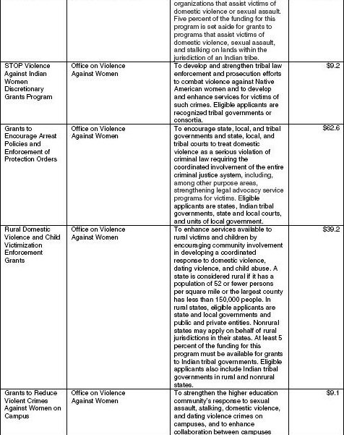
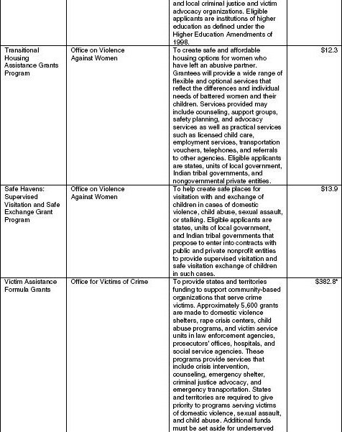
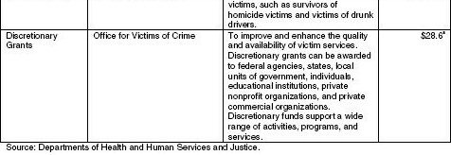

© 2005 - 2008 True Equality Network – All rights reserved – www.True-Equality.org. Used with permission.

