FREE
Family Law Reform t-shirt
with your donation to CPR

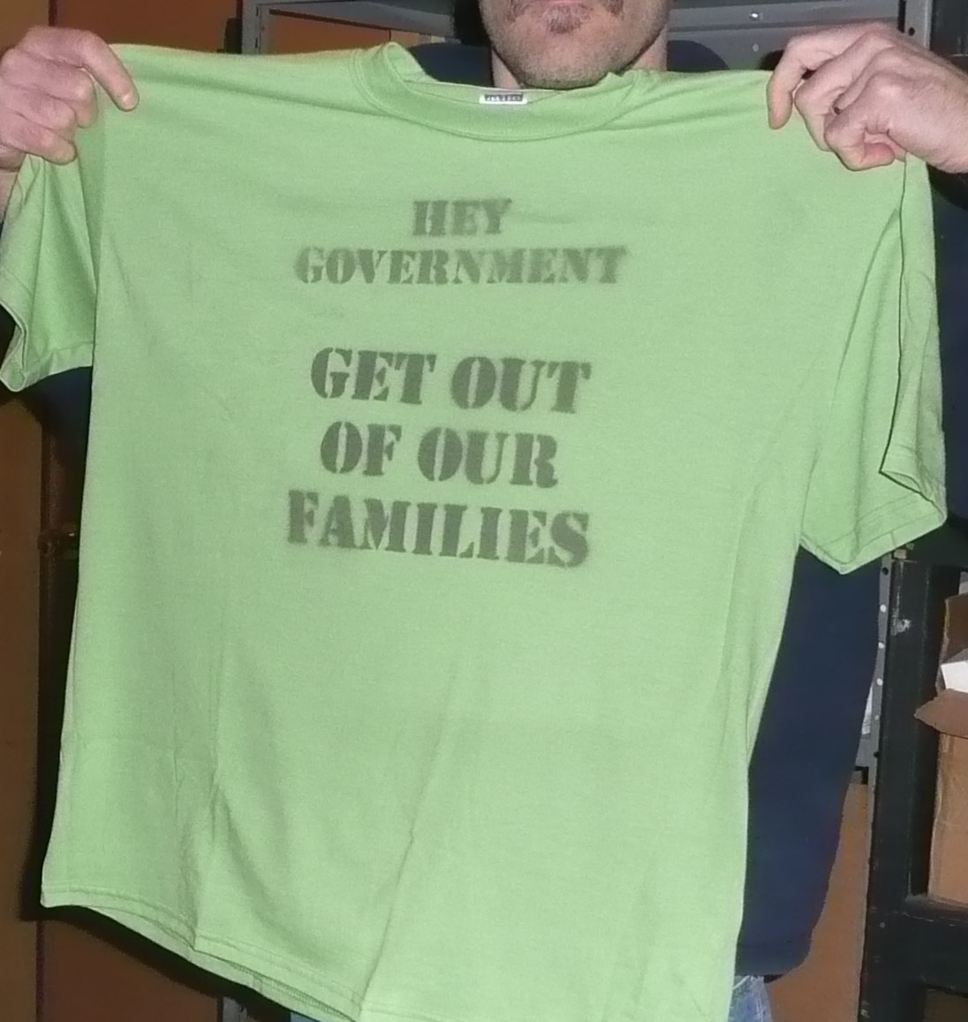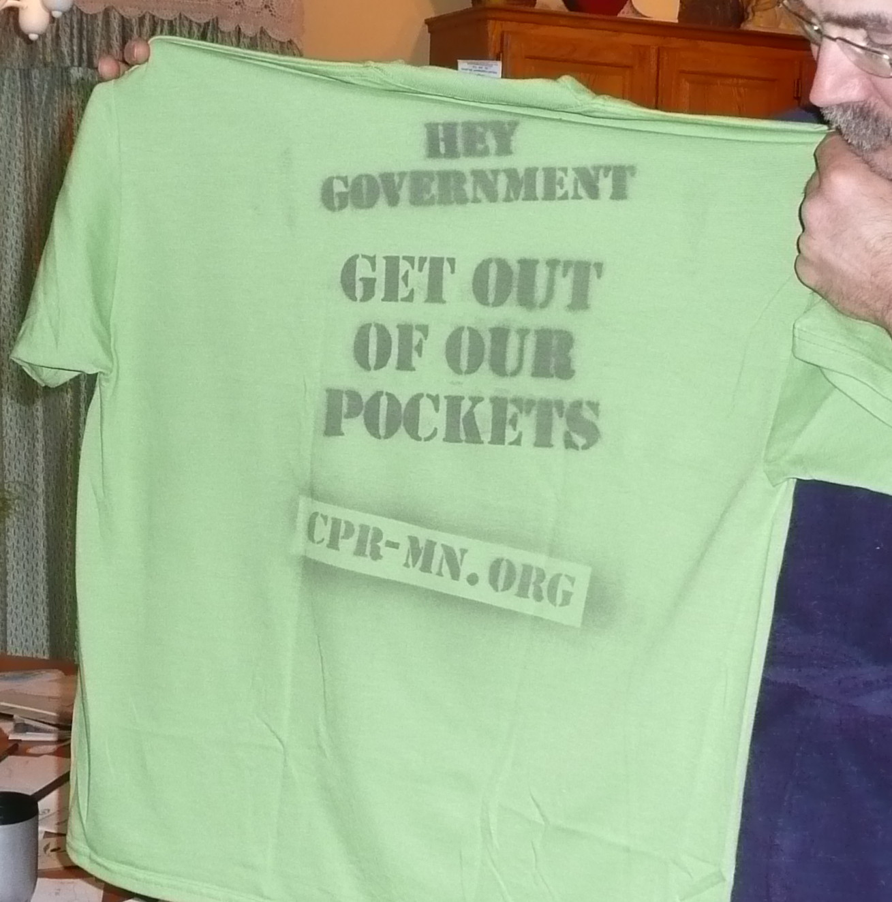
FRONT OF T-SHIRT BACK OF T-SHIRT

Solution: Joint Physical Custody Solution: IV-D Eligibility Standards and Means Testing

Name: _______________________________________________ (PRINT)

Mailing Address: _______________________________________________ (street)

_______________________________________________ (city, state, zip)

Email: _______________________________________________ (PRINT legibly)

Phone: _______________________________________________ (Circle if: Home Cell Work)

Quantity of t-shirts: ________ Size of t-shirt: S M L XL XXL

Suggested Donation: $28, includes $8.00 for shipping & handling

MAIL YOUR DONATION TO: CPR P.O. Box 130776 Roseville, MN 55113
Receipts will be mailed to you with your shirt.

