Minneapolis-St.Paul, MN Printed January 20, 2011
http://www.startribune.com/local/114246189.html?elr=KArksUUUoDEy3LGDiO7aiU

Backer sees hope at last for joint-custody legislation

Molly Olson checked in this week with an e-mail message bursting with something unusual: optimism.

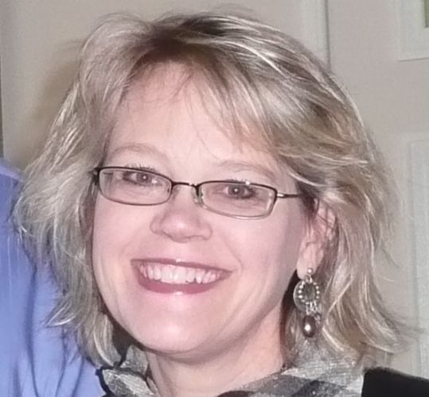
Cautious optimism, admittedly. But those of us who have long rooted for Olson's tireless efforts on behalf of families will take what we can get.

"Nothing is ever a sure thing, and there are always surprises at the Legislature," said Olson, volunteer founder of the nonpartisan Minnesota-based Center for Parental Responsibility (www.cpr-mn.org1). "But there is a strong degree of confidence among legislators that JPC will pass both the House and the Senate this session."

JPC is Joint Physical Custody, a bill presuming equally shared parenting after divorce. It's a nod to dads, who are too often marginalized in custody disputes.

In a 2009 review by CPR of divorce files in seven Minnesota counties, for example, Ramsey County awarded sole physical custody to mothers 70 percent of the time. It's a reality Olson calls "pretty pathetic."

A growing number of politicians, lawyers, grandparents, second spouses and even mothers agree.

"I met with one divorced mother who told me, 'I absolutely cannot stand my ex, but my kids really need their dad.' They're giving their kids a chance," Olson said, "and that's what kids need."

Olson, who is married, is not a parent. She's driven by her abiding love for her grandfather and both parents, a gift she feels all kids deserve. For nearly a dozen years, Olson has volunteered thousands of hours to family-law reform. As CPR founder, she's carted around a suitcase filled with policy papers and research on the importance of shared parenting. She's talked to politicians, judges and case workers. She's started a cable TV show and participated in numerous legislative study groups.

And for nearly a dozen years, she's met resistance every time she tries to get family-friendly Minnesota to pass JPC.

So, why the optimism this go-round?

Longevity, for starters. Olson has spent 11 years listening to people on all sides of this intensely emotional issue, addressing their concerns and massaging the bill to reflect their feedback.

"We want to make sure we understand all the nuance, so that in the bill we clarify as many of those things as possible to avoid additional conflict for divorcing couples."
One key concern is domestic violence, which the bill addresses head-on. "Every bill we've introduced makes domestic abuse an exception," Olson has said numerous times. "No, you don't qualify for shared parenting in that case."
Secondly, Olson is heartened by the warmth emanating her way from the Capitol since November. "Every year, committee chairs were very resistant to this. This year, they've already agreed to hear our bill. They're willing to meet about it right away." She has at least three meetings a week currently. "These are legislators who see the importance of re-evaluating what we're doing in family court."
Maybe most telling, Olson said, is what is happening inside homes across the state, far away from the courts or Capitol. Society is changing, Olson said. Now laws are catching up with those changes.
Legislators, she said, "are flooding us with stories they've heard from constituents, and from their own families in some cases. It appears that the majority of divorcing couples are moving away from every other weekend and moving toward more shared parenting, in spite of the law."
Co-parenting classes, required by law, are helping too, Olson said, "teaching the importance of communication and cooperation of parents for the sake of the children."
Not everyone who cares about families supports JPC, of course. Hennepin County Judge Bruce Peterson, formerly a presiding judge of Family Court, said he worries that a presumption of shared parenting "distracts" from other more promising efforts. Those include Early Neutral Evaluation, a program that works to divert divorcing couples from costly, drawn-out legal battles, as well as case-management conferences and a focus on the needs of never-married parents.
"I prefer a focus on reducing conflict," Peterson said, "rather than on what are perceived to be advantages given to mothers and fathers."
Olson isn't slowing down. She was on her way Wednesday night to yet another meeting with another group of lawmakers interested in implementation of JPC, "who wanted to be sure they really understood and none of us were shooting from the hip." She was more than happy to oblige.
"Part of me wants to just think it's a slam dunk," Olson said, "but I'm holding back."

Gail Rosenblum • 612-673-7350 • gail.rosenblum@startribune.com

