CPR Center for Parental Responsibility
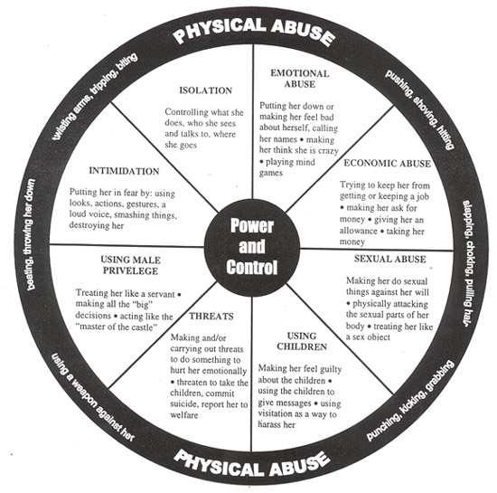
Wheel of Violence
Know How Your Actions Can be Interpreted As Domestic Abuse – just about anything can!

CPR Commentary:
This wheel is a standard chart used by many agencies receiving government funds. Because it is gender specific and not gender neutral, it creates bias and might even be unlawful.

All research shows that abuse is equal among each gender.

This wheel was created by the Domestic Violence Project; Duluth, Minnesota. The image was scanned from the Domestic and Dating Violence Information and Resource Handbook (created by the Metropolitan King County Council, Washington).  Using Coercion and Threats- Making and/or carrying out threats to do something to hurt her. Threatening to leave her, to commit suicide, to report her to welfare. Making her drop charges. Making her do illegal things.  Minimizing, Denying, and Blaming- Making light of the abuse and not taking her concerns seriously. Saying the abuse didn't happen. Shifting responsibility for abusive behavior. Saying she caused it.  Using Male Privilege- Treating her like a servant. Making all the big decisions. Acting like the "master of the castle". Being the one to define men's and women's roles. |  | Using Intimidation- Making her afraid by using looks, actions, gestures. Smashing things. Destroying her property. Abusing pets. Displaying weapons.  Using Emotional Abuse- Putting her down. Making her feel bad about herself. Calling her names. Making her think she is crazy. Playing mind games. Humiliating her. Making her feel guilty.  Using Isolation- Controlling what she does, who she sees and talks to, what she reads, where she goes. Limiting her outside involvement. Using jealousy to justify actions.  Using Children- Making her feel guilty about the children. Using the children to relay messages. Using visitation to harass her. Threatening to take the children away.  Using Economic Abuse- Preventing her from getting or keeping a job. Making her ask for money. Giving her an allowance. Taking her money. Not letting her know about or have access to family income.
See reverse side for NON-VIOLENCE WHEEL ➔

CPR INFORMATION IS POWER: most divorce attorneys will tell their female clients to look for and even provoke any behavior that could be considered abuse by the man, in order for the female to gain a sure advantage in the custody battle. Your best defense is a good offense. Don’t get sucked in. Be sure you are supporting non-violence behavior. Don’t be afraid to identify yourself as a victim and document when it is in fact the female’s violent behavior causing problems. But documentation and witnesses are the key. Remember, the courts are bias, and as a man, your word means nothing in court.

Non-Violence Wheel
The Non-Violence Wheel offers a view of a relationship that is based on equality and non-violence. Use this chart to compare the characteristics of a non-violent relationship to those of an abusive relationship (see Violence Wheel). The Non-Violence Wheel is also helpful in setting goals and boundaries in personal relationship.
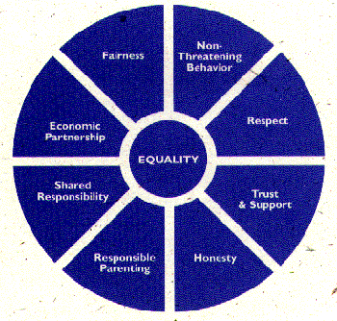

Adapted from the Domestic Abuse Intervention Project - Duluth, MN

(Reprinted by permission of Peace At Home (formerly Battered Women Fighting Back), Boston; Ph 617-482-9497; Fax 617-482-6504)

